**Title of the paper for the ICIBAB 2019 (TNR, Bold 14)**

**First Author**1,**\*, Second AUTHOR**2**, Third AUTHOR**3(TNR, Bold 12)

*Affiliation1*

*Affiliation2*

*Affiliation3*

*\*For correspondence: Email:* [*umoren@kfupm.edu.sa*](mailto:umoren@kfupm.edu.sa)

**Abstract**

Maximum 300 words in Times New Roman of size 12. (No more than one page (including the figure below)).

***Keywords*:** Maximum 5 words.

Please make a brief schematic diagram. Please make sure that this can illustrate your work briefly.

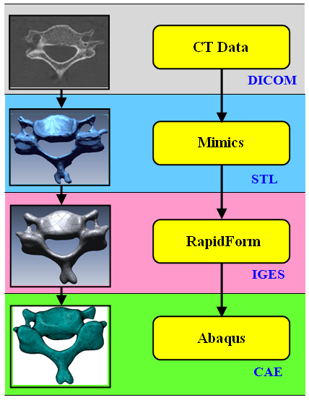 

Sample of schematic diagram.